Second Trial Report
Germination and Early Growth Monitoring Using RGB and Multispectral Image Analysis

RINA Internship Project
Research Institute for Northern Agriculture (RINA)
Charles Darwin University - PRT604 Internship
Prepared by: Shibbir Turag
Supervisor: Professor Stephen Xu
Report focus: Second Trial image-analysis workflow and results

Table of Contents
Executive Summary | 3
1. Introduction | 3
2. Aim and Objectives | 4
3. Trial Design and Data Structure | 4
4. Image Processing Methodology | 5
5. RGB Emergence and Green-Cover Results | 6
6. Multispectral NDVI and NDRE Results | 9
7. Final Synthesis and Treatment Interpretation | 12
8. Discussion | 15
9. Limitations | 16
10. Conclusion | 16
Appendix A: Report Package and Supporting Outputs | 17

Executive Summary
This report presents the completed Second Trial image-analysis workflow for monitoring germination and early seedling growth. The workflow combined D/RGB imagery for visible emergence and green-cover analysis with multispectral imagery for relative NDVI and NDRE analysis. The final synthesis ranked trays and treatment groups by combining RGB and multispectral indicators into one descriptive evidence package.
Across all trays, tracked visible emergence increased from 36.96% on Day 1 to 70.71% on Day 5, and then to 74.29% by the Day 9 follow-up. This shows that the main visible emergence period occurred between Day 1 and Day 5, with a smaller additional increase by Day 9.
The strongest treatment x environment group in the final synthesis was Microbes | Inside, with a mean overall observed performance score of 81.21. The two highest ranked individual trays were Tray 8 (Microbes | Inside, score 85.41) and Tray 5 (Microbes | Inside, score 77.01). Both were Microbes Inside trays, indicating that this treatment placement showed the strongest combined image-derived performance in the Second Trial.
At the broader Microbes versus No Microbes level, the treatment result was more mixed. Microbes had higher Day 5 emergence and RGB green-cover values, but the overall treatment-level score was slightly higher for No Microbes because the Microbes Outside trays performed poorly and reduced the microbial treatment average. Therefore, the most reliable interpretation is not that all microbial trays performed better, but that the Microbes Inside placement performed best while Microbes Outside performed weakest.
The results are descriptive and image-derived. They should not be interpreted as formal statistical proof because each treatment x environment group contained only two trays. The analysis nevertheless provides a structured and repeatable evidence base for the Second Trial report and for later comparison with the First Trial and future Third Trial.

1. Introduction
Germination and early seedling development can be monitored using repeated imagery when the images are processed in a consistent and validated workflow. In this internship project, tray-level and cell-level images were used to assess emergence, green-cover development, and multispectral vegetation-index response across treatment groups. The Second Trial extended the earlier workflow by combining RGB and multispectral evidence streams into one integrated analysis.
The trial used a fixed tray structure with 70 planting cells per tray. This structure made it possible to analyse emergence and growth at both the cell level and the tray level. The RGB workflow was used to measure visible emergence and green-cover response, while the multispectral workflow was used to calculate relative NDVI and NDRE values from aligned multispectral bands.
A key requirement of this report is to present the completed workflow and the final results in a form suitable for the internship documentation. For this reason, the report emphasises both methodology and interpretation. The report also identifies limitations, including the use of relative image-derived indices and the small number of trays within each treatment x environment group.

2. Aim and Objectives
The aim of the Second Trial was to evaluate early germination and growth response across microbial and placement treatments using RGB and multispectral image analysis.
The specific objectives were to:
- process the Second Trial image set using a consistent and reproducible workflow;
- detect the fixed 7 x 10 tray-cell structure and assign one square ownership zone to each planting cell;
- measure visible emergence and RGB green-cover development from Day 1 to Day 5 and at the Day 9 follow-up;
- calculate relative NDVI and NDRE values from multispectral images using an independent multispectral cell grid;
- compare Microbes versus No Microbes, Inside versus Outside, and the four combined treatment x environment groups;
- create a final Second Trial synthesis table and report-ready figure package for the internship report.

3. Trial Design and Data Structure
The Second Trial included six observation days: Day 1, Day 2, Day 3, Day 4, Day 5, and Day 9. Day 1 to Day 5 were treated as the continuous early growth period. Day 9 was treated as a later follow-up observation and was not treated as one day after Day 5 for growth-rate calculations.
Each observation day contained eight trays. Each tray contained a fixed 7 x 10 lattice, giving 70 planting cells per tray. Therefore, each day contained 560 possible cell observations across the full trial. Each cell was assumed to contain one seed.
Table 1. Second Trial treatment layout.
Tray | Treatment | Environment
Tray 1 | No Microbes | Inside
Tray 2 | No Microbes | Inside
Tray 3 | No Microbes | Outside
Tray 4 | No Microbes | Outside
Tray 5 | Microbes | Inside
Tray 6 | Microbes | Outside
Tray 7 | Microbes | Outside
Tray 8 | Microbes | Inside

The four combined treatment x environment groups were No Microbes Inside, No Microbes Outside, Microbes Inside, and Microbes Outside. Each combined group contained two trays. This group size is sufficient for descriptive comparison but not sufficient for strong inferential statistical claims.

4. Image Processing Methodology
The image-processing workflow was organised into numbered scripts. Each script produced a separate output folder so that intermediate results, reports, and quality-control files could be checked before continuing to the next stage.
Table 2. Second Trial image-processing workflow.
Script | Purpose
01 | Crop D/RGB and multispectral images using separate references.
03 | Detect the D/RGB 70-cell grid using square ownership zones.
04 | Measure visible emergence and RGB green-cover evidence for each cell and tray.
05 | Compare RGB emergence and green-cover results by treatment group.
06 | Detect an independent 70-cell grid for multispectral images.
07 | Calculate relative NDVI and NDRE values from multispectral bands.
08 | Compare NDVI and NDRE results by treatment group and create a PDF report.
09 | Combine RGB and multispectral results into a final Second Trial synthesis.
10 | Collect final report-ready figures, reports, workbooks, and CSV tables.

4.1 Cropping and Image Organisation
Raw images were cropped into tray-specific D/RGB and multispectral outputs. The cropping process used separate references for the D/RGB images and the multispectral images. This was necessary because RGB and multispectral images did not share exactly the same geometry. The F band was not used in the vegetation-index workflow.

4.2 RGB Cell-Grid Detection
The D/RGB workflow used a fixed 7 x 10 grid. The final analysis used square ownership zones rather than circular zones because seedlings can emerge slightly outside the cup area while still belonging to the original planting cell. The Script 03 RGB grid-detection run produced 48 automatic passes across the complete Second Trial D/RGB dataset.

4.3 Visible Emergence and RGB Green-Cover Detection
Script 04 measured two related RGB indicators. The first indicator was raw current green evidence, which recorded whether green evidence was detected in a cell on a specific observation day. The second indicator was tracked visible emergence, where a cell remained counted as emerged after its first positive detection. This preserved both daily detection information and cumulative emergence status.

4.4 Multispectral Grid Detection and Vegetation Indices
The multispectral workflow used an independent 70-cell grid based on the MS_NIR band. This grid was then applied to the aligned MS_G, MS_R, MS_RE, and MS_NIR bands. The RGB grid was not transferred directly to the MS images because the crop geometry differed between the image groups.
Relative NDVI and NDRE were calculated using the following formulas:
NDVI = (MS_NIR - MS_R) / (MS_NIR + MS_R)
NDRE = (MS_NIR - MS_RE) / (MS_NIR + MS_RE)
The values are described as relative image-derived vegetation indices. Unless the source multispectral imagery is confirmed to be calibrated reflectance data, the NDVI and NDRE values should be used for relative comparison within the same workflow rather than as absolute field-calibrated vegetation measurements.

4.5 Final Synthesis and Report Package
Script 09 combined RGB emergence, RGB green cover, NDVI, NDRE, and treatment mapping into one master synthesis table. Script 10 then collected the final report-ready outputs into a clean package containing figures, PDF reports, Excel workbooks, and CSV tables. The package manifest showed 24 copied files and no missing package files.

5. RGB Emergence and Green-Cover Results
The RGB analysis showed a clear increase in tracked visible emergence over time. The largest increase occurred during the Day 1 to Day 5 window, which was used as the continuous early growth period. Day 9 showed additional emergence but was treated as a follow-up observation.
Table 3. Overall tracked emergence and RGB green-cover progression.
Day | Tracked emerged cells | Total cells | Emergence (%) | RGB green cover proxy (%)
Day 1 | 207 | 560 | 36.96 | 0.313
Day 2 | 313 | 560 | 55.89 | 0.889
Day 3 | 348 | 560 | 62.14 | 1.132
Day 4 | 384 | 560 | 68.57 | 1.362
Day 5 | 396 | 560 | 70.71 | 1.705
Day 9 | 416 | 560 | 74.29 | 4.082

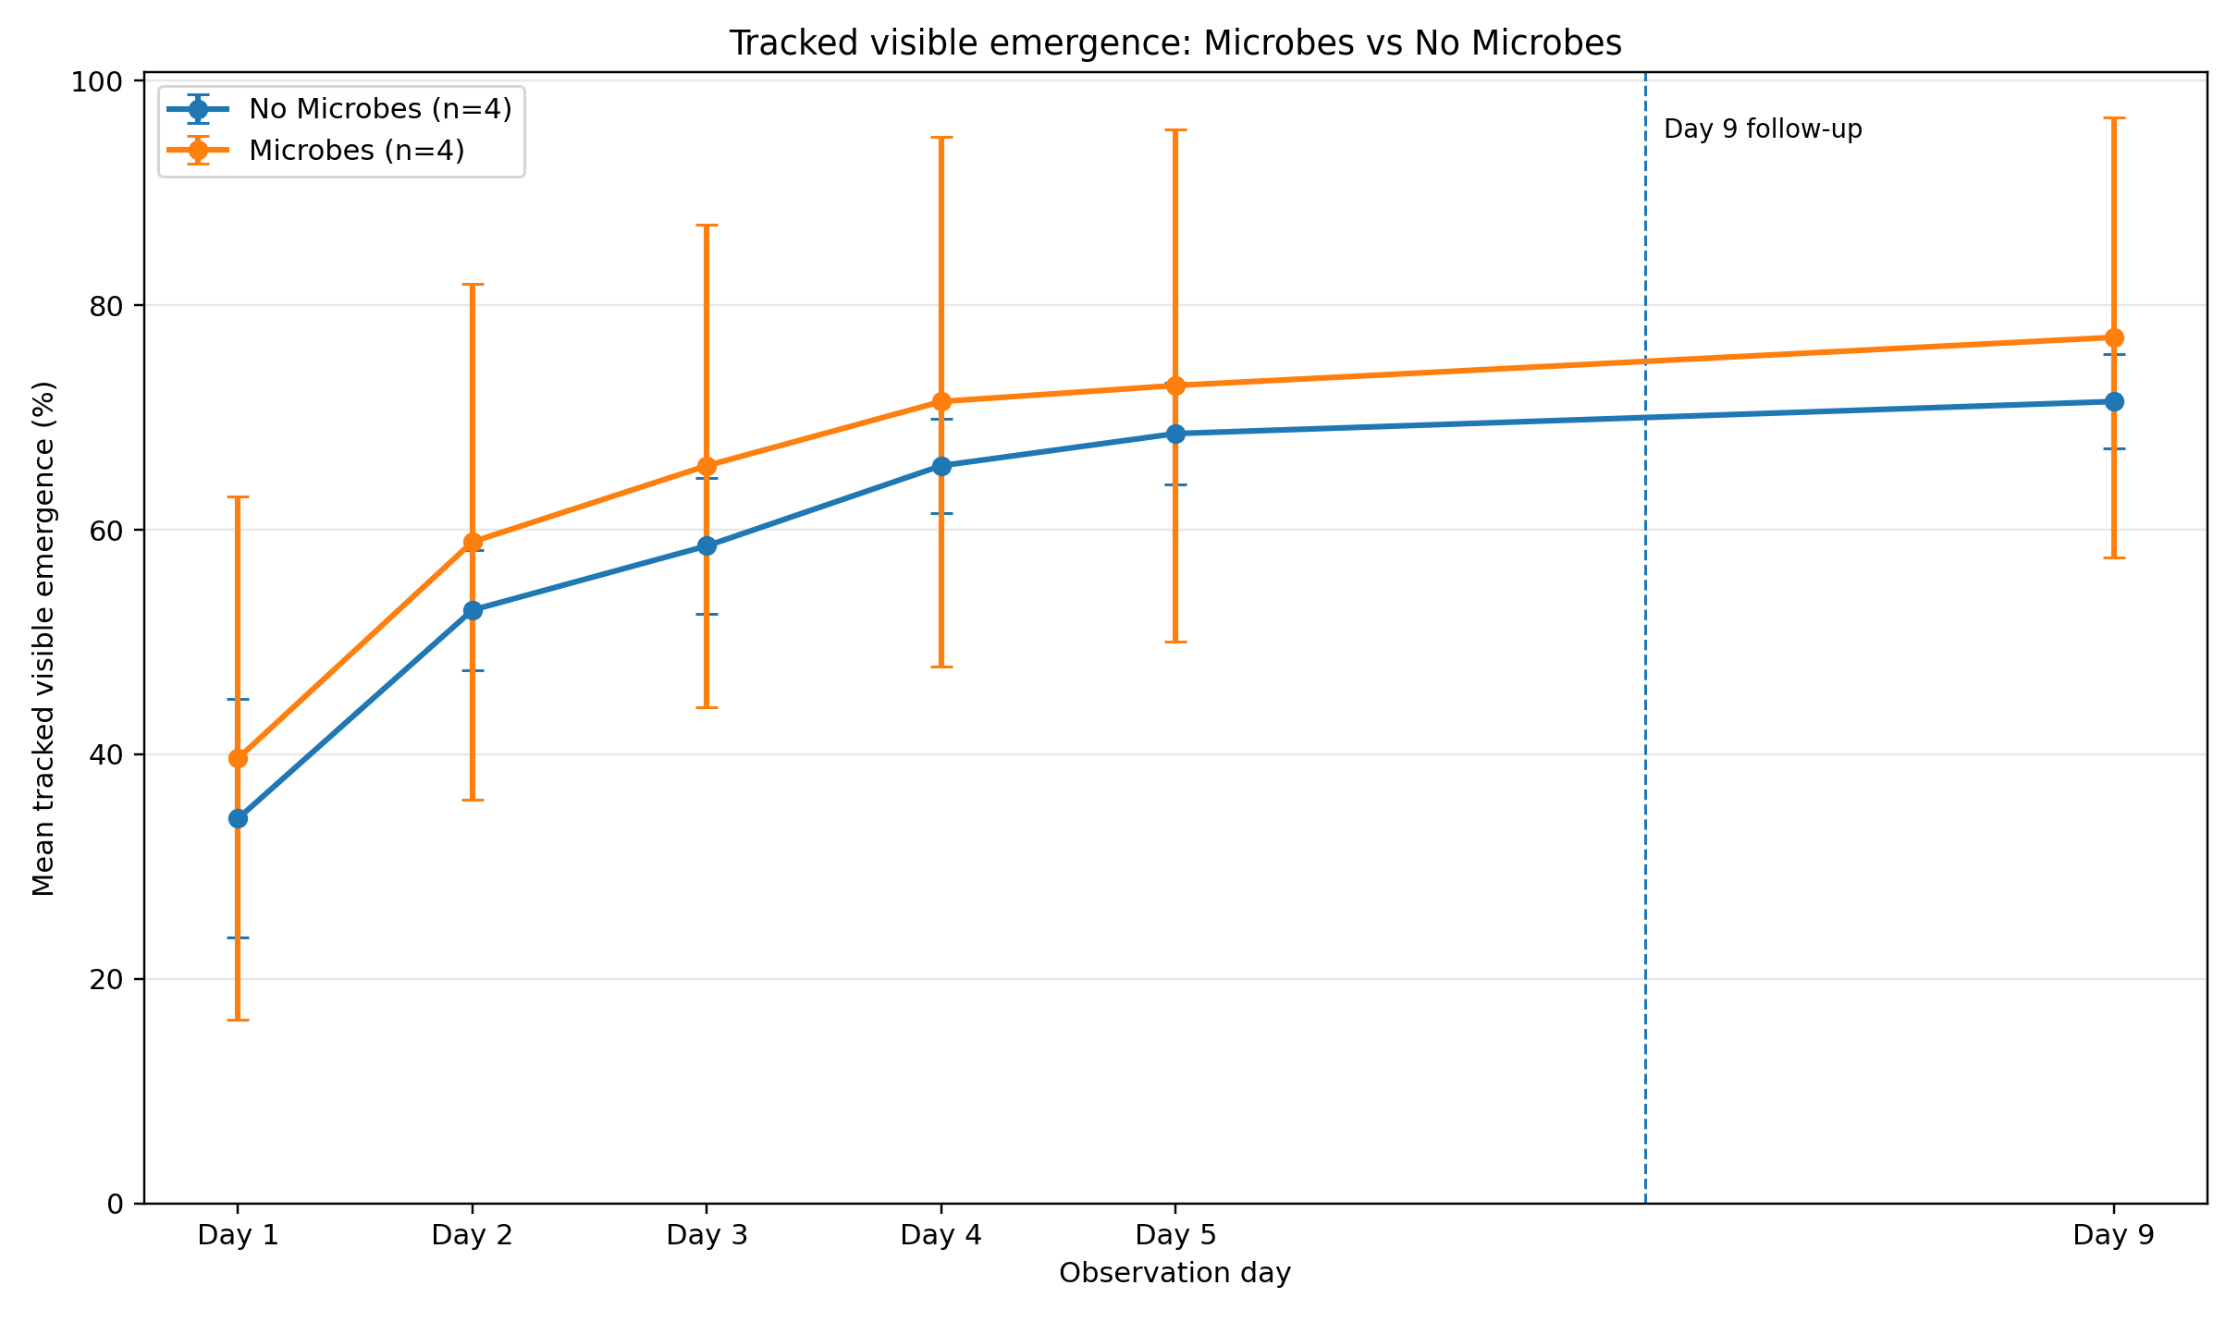
Figure 1. RGB tracked emergence trend by treatment.
Tracked visible emergence increased from 36.96% on Day 1 to 70.71% on Day 5. This represented an increase from 207 emerged cells to 396 emerged cells out of 560 total cells. By Day 9, emergence reached 74.29%, equivalent to 416 emerged cells. This pattern indicates that the first five observation days captured the main emergence period.
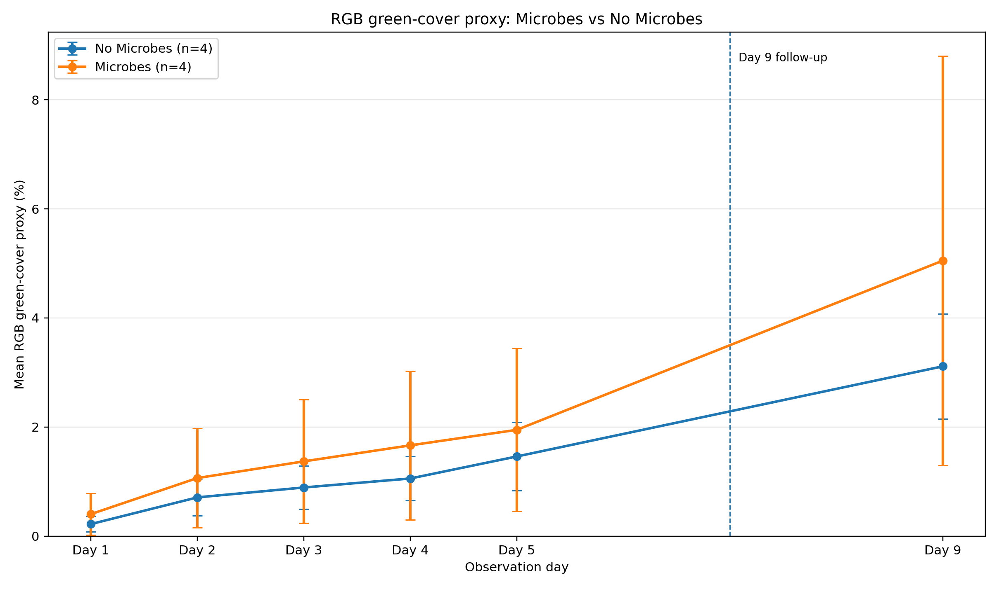
Figure 2. RGB green-cover trend by Microbes versus No Microbes treatment.
At the treatment level, Microbes trays reached a mean Day 5 tracked emergence of 72.86%, compared with 68.57% for No Microbes trays. Microbes trays also showed a higher mean Day 5 RGB green-cover proxy (1.949%) than No Microbes trays (1.461%).
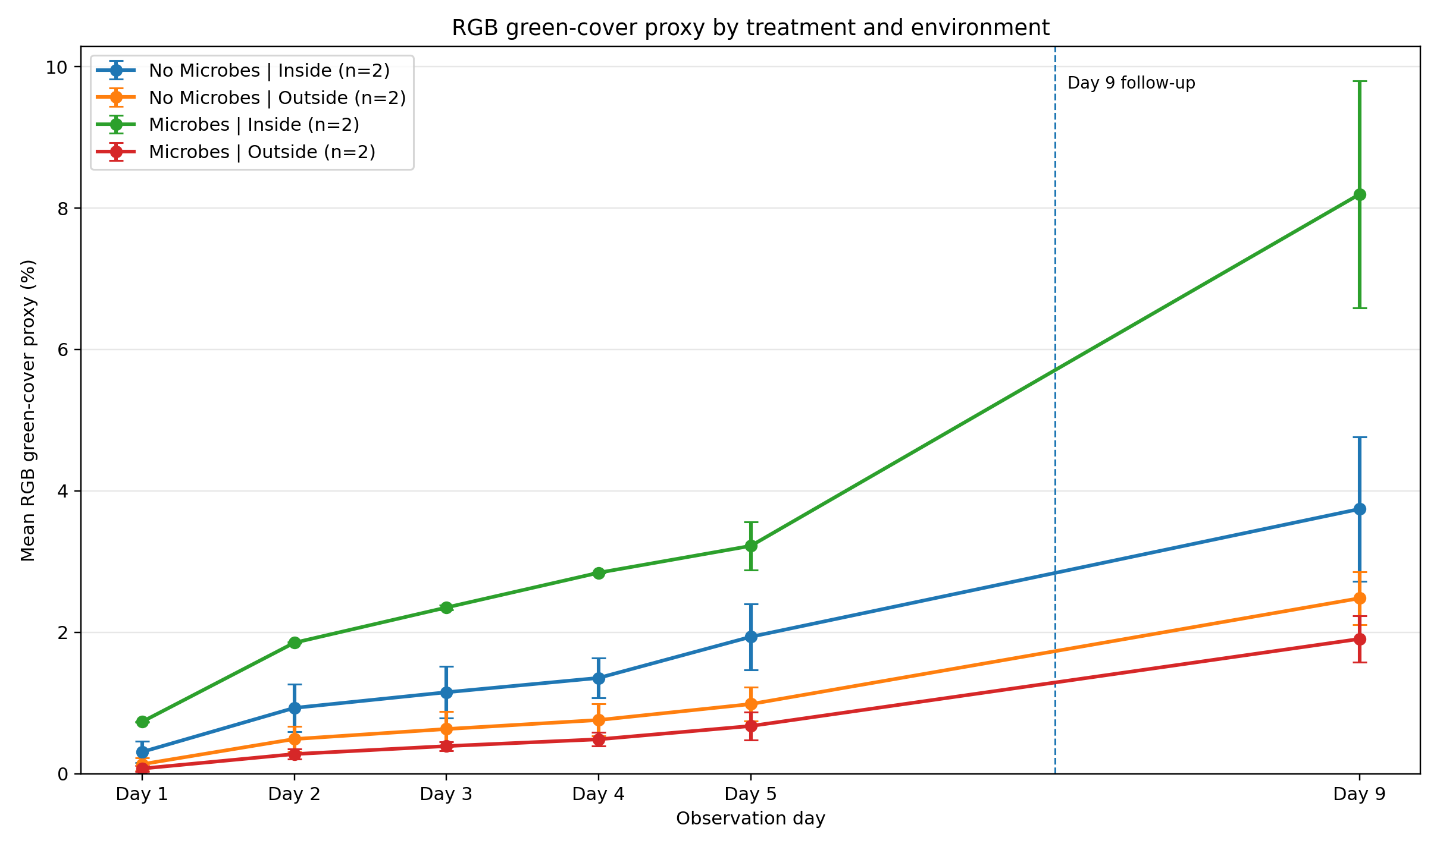
Figure 3. RGB green-cover trend by treatment x environment group.
The interaction-level RGB results were more informative than the broad treatment comparison. Microbes Inside reached a mean Day 5 emergence of 92.14% and a mean Day 5 RGB green-cover proxy of 3.223%. This was higher than the other treatment x environment groups. In contrast, Microbes Outside had the lowest Day 5 emergence (53.57%) and the lowest mean overall score.
Table 4. Day 9 tracked emergence by tray.
Tray | Group | Day 9 emerged cells | Day 9 emergence (%)
Tray 1 | No Microbes | Inside | 52 | 74.29
Tray 2 | No Microbes | Inside | 53 | 75.71
Tray 3 | No Microbes | Outside | 48 | 68.57
Tray 4 | No Microbes | Outside | 47 | 67.14
Tray 5 | Microbes | Inside | 68 | 97.14
Tray 6 | Microbes | Outside | 39 | 55.71
Tray 7 | Microbes | Outside | 46 | 65.71
Tray 8 | Microbes | Inside | 63 | 90.00

At Day 9, the strongest individual trays by visible emergence were Tray 5 and Tray 8, both belonging to the Microbes Inside group. Tray 5 reached 68 emerged cells out of 70 and Tray 8 reached 63 emerged cells out of 70. This confirms that the Microbes Inside group performed strongly in visible emergence.

6. Multispectral NDVI and NDRE Results
The multispectral workflow calculated relative NDVI and NDRE for each tray using Script 07. These values provided a second evidence stream to support or challenge the visible RGB interpretation. The MS analysis included one missing accepted Day/Tray record in the intermediate daily data: Tray 2, Day 3. However, the key Day 1, Day 5, and Day 9 metrics used in the final synthesis were available for the final tray-level summary.
Table 5. Treatment-level multispectral and synthesis indicators.
Treatment | Mean Day 5 NDVI | Mean Day 5 NDRE | Mean NDVI rate/day | Mean NDRE rate/day | Overall score
Microbes | 0.2899 | -0.0637 | -0.0028 | -0.0012 | 52.32
No Microbes | 0.2977 | -0.0689 | -0.0001 | -0.0001 | 53.32

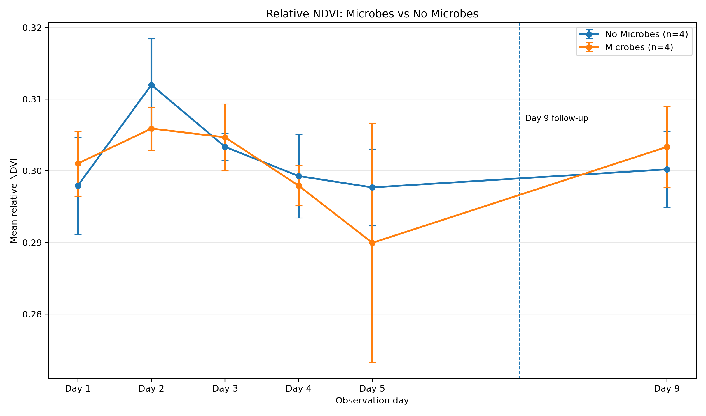
Figure 4. Relative NDVI trend for Microbes versus No Microbes.
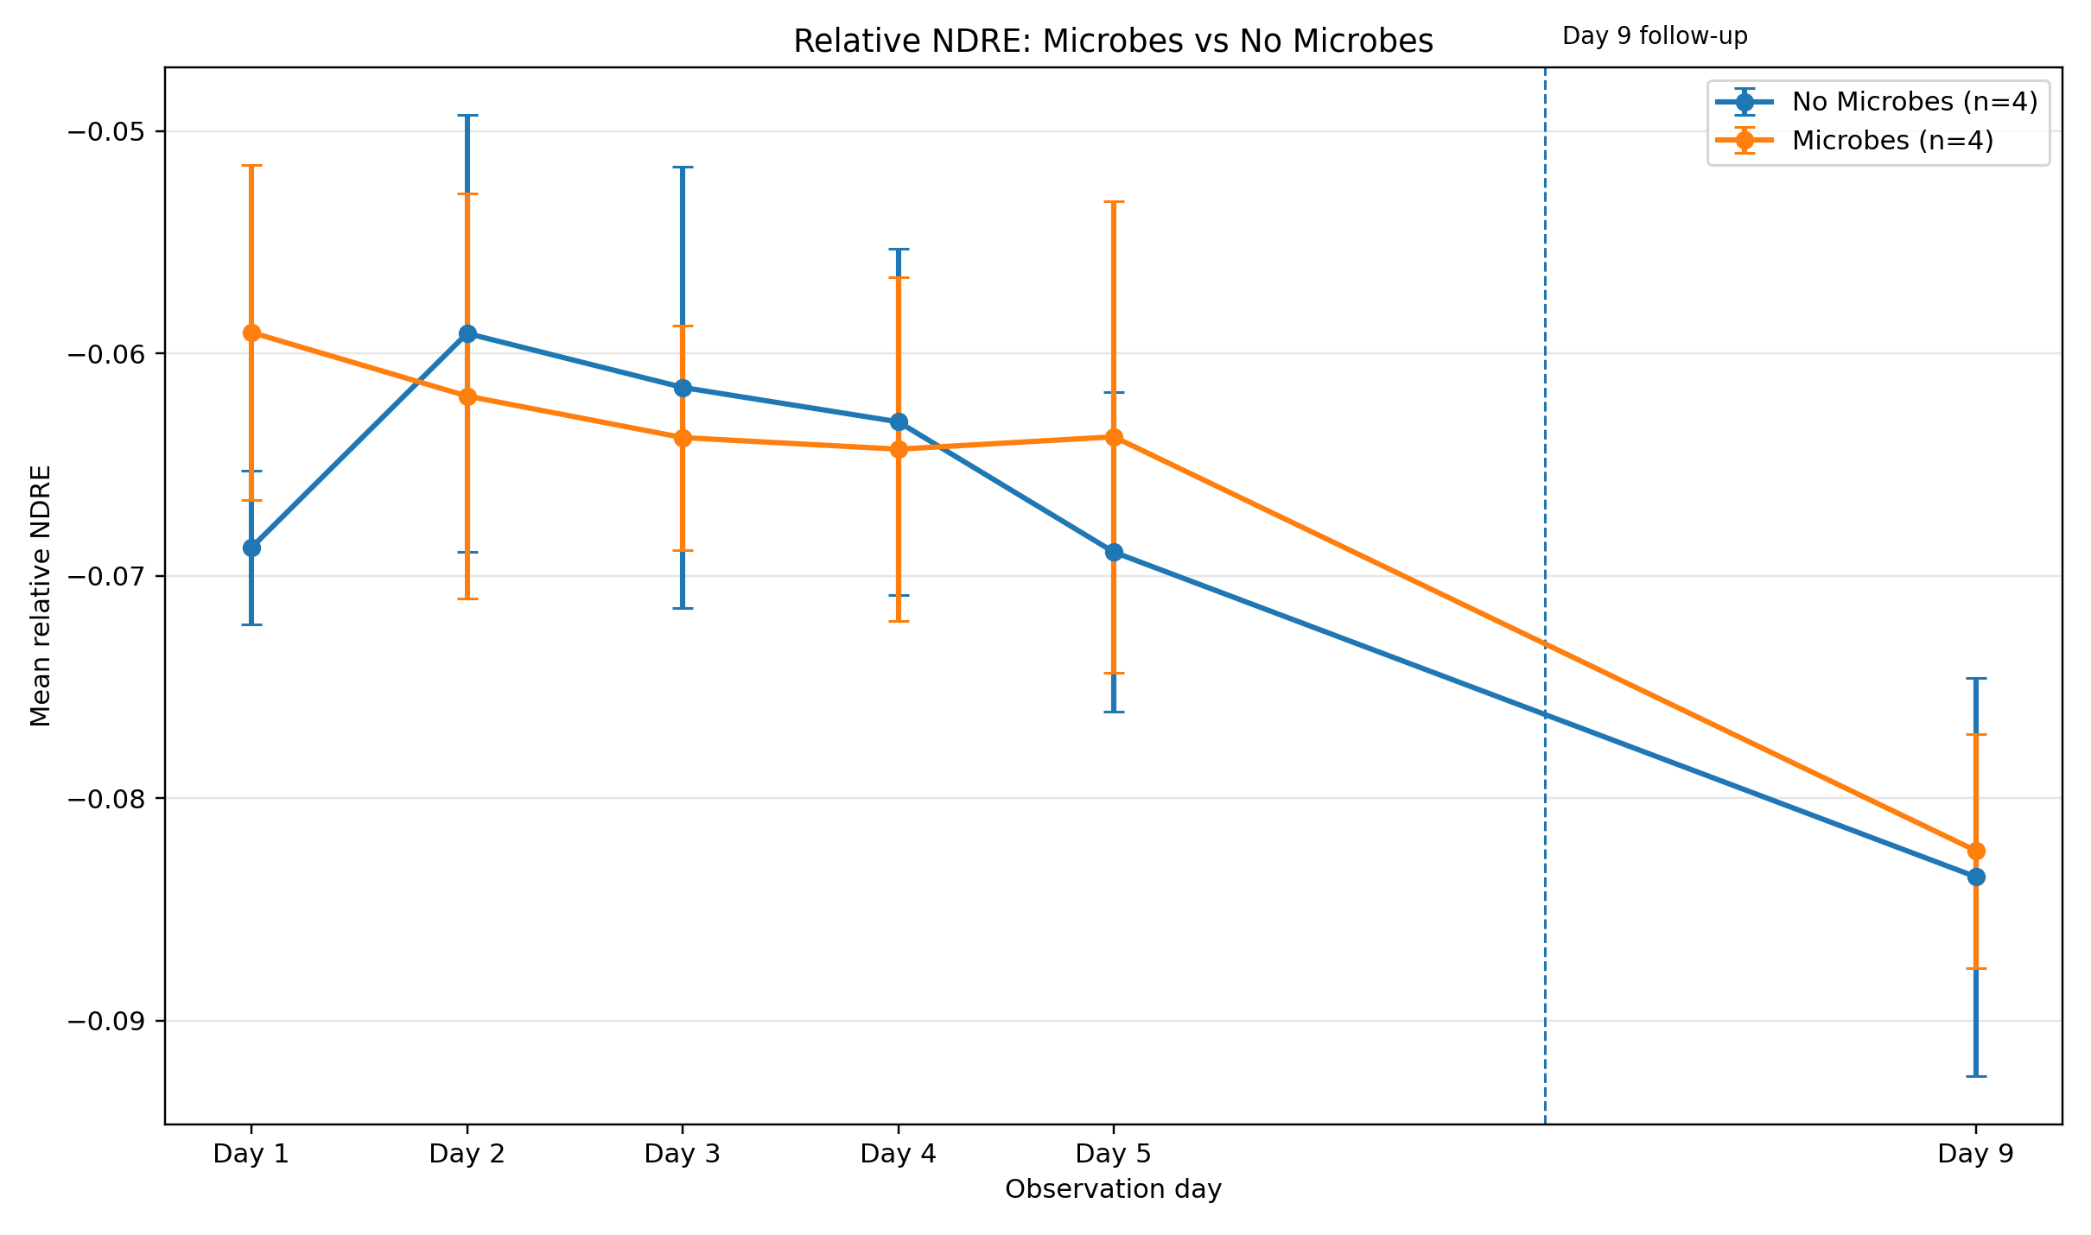
Figure 5. Relative NDRE trend for Microbes versus No Microbes.
At the broad treatment level, No Microbes had a higher mean Day 5 NDVI (0.2977) than Microbes (0.2899). In contrast, Microbes had a less negative and therefore higher Day 5 NDRE (-0.0637) than No Microbes (-0.0689). These mixed spectral patterns show why the multispectral outputs should be interpreted together with the RGB results rather than in isolation.
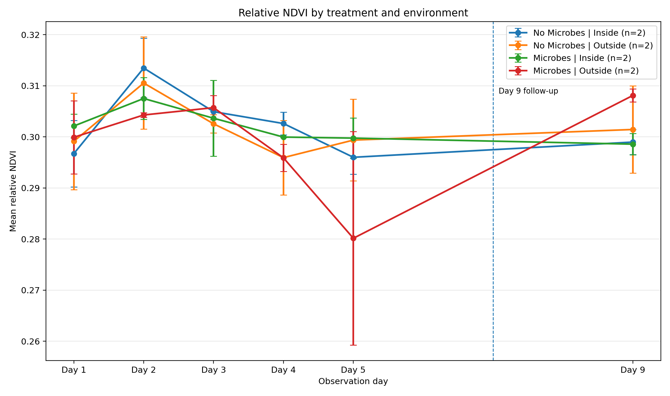
Figure 6. Relative NDVI by treatment x environment group.
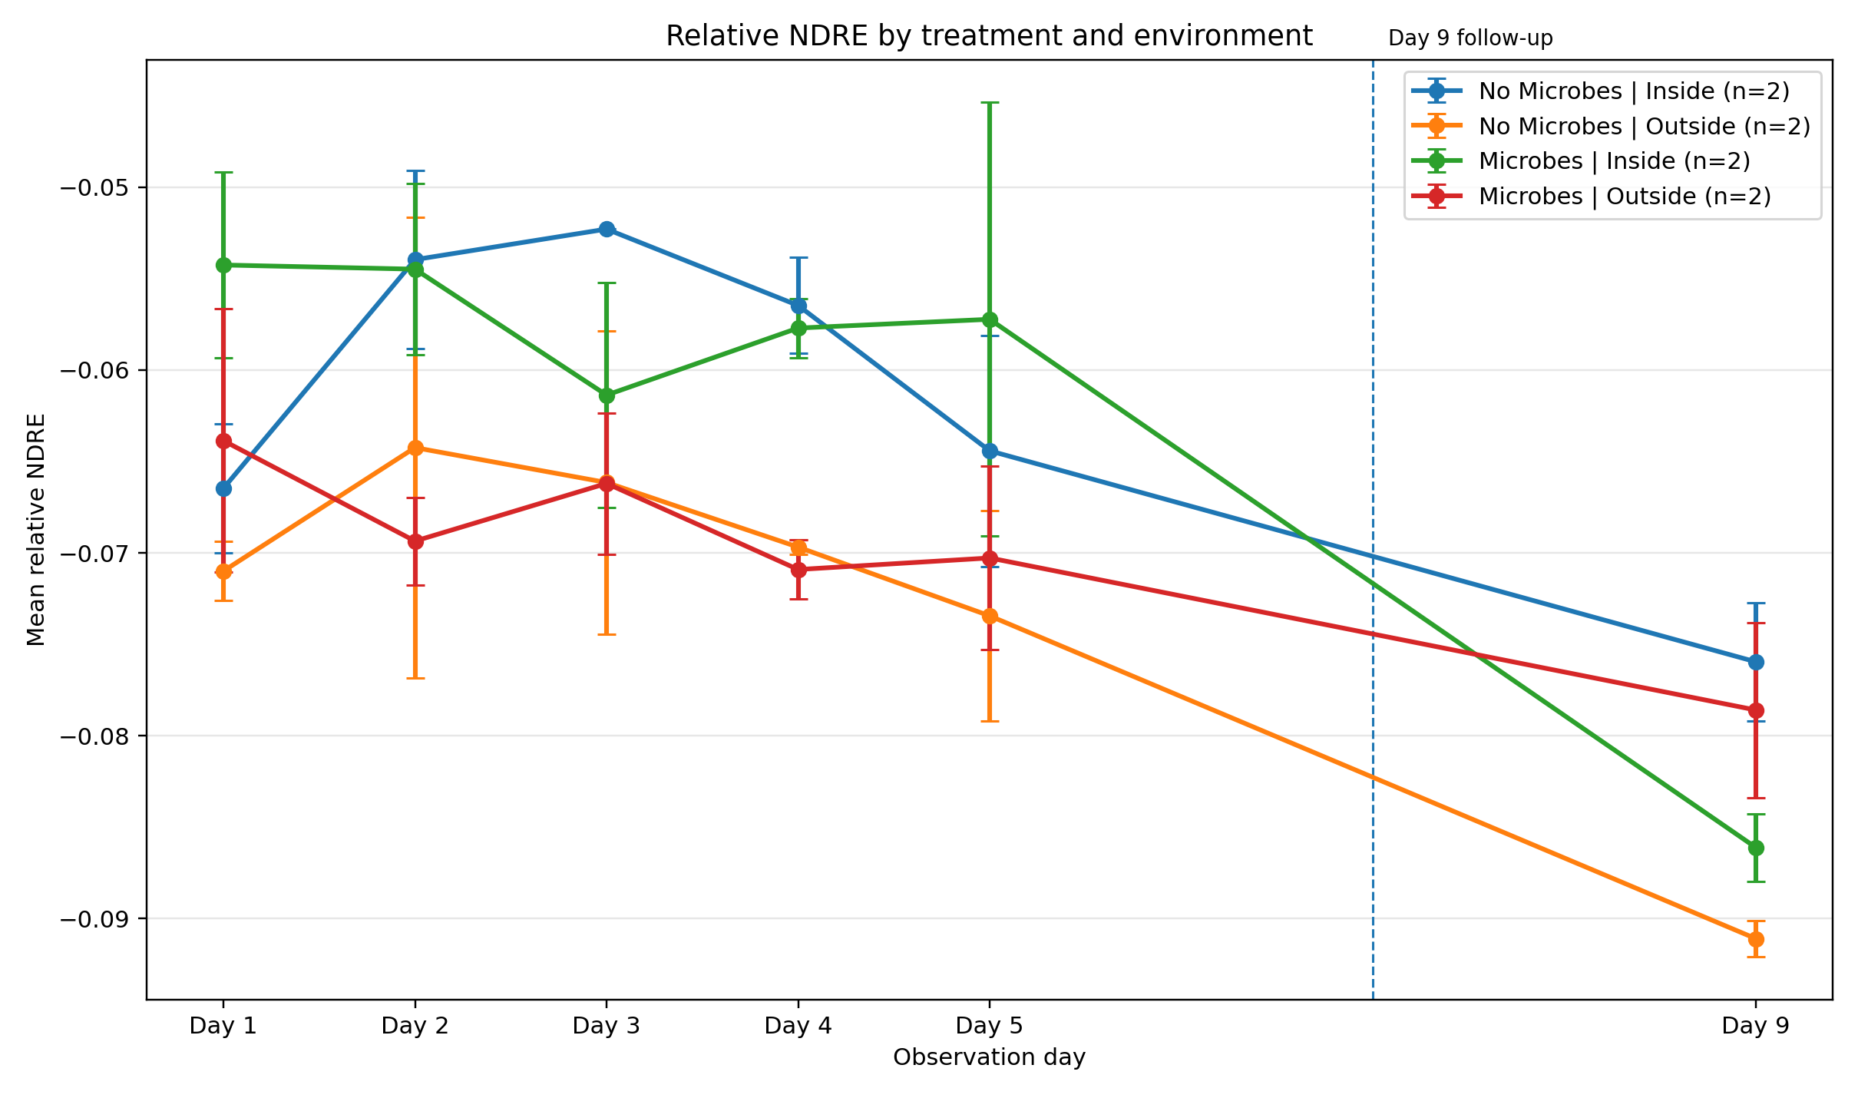
Figure 7. Relative NDRE by treatment x environment group.
At the interaction level, Microbes Inside recorded the highest mean Day 5 NDVI among the combined groups (0.2997 and the highest mean Day 5 NDRE (-0.0572). The Microbes Outside group showed the weakest combined performance, including lower Day 5 NDVI (0.2801) and lower overall score. This supports the interpretation that placement condition strongly affected the microbial treatment response.

7. Final Synthesis and Treatment Interpretation
The final synthesis combined RGB and multispectral metrics into one master summary table. The overall observed performance score was calculated descriptively by min-max normalising selected indicators across trays and then averaging available component scores. The score included Day 5 tracked emergence, Day 5 RGB green cover, Day 5 NDVI, Day 5 NDRE, Day 1 to Day 5 green-cover rate, Day 1 to Day 5 NDVI rate, and Day 1 to Day 5 NDRE rate.
Table 6. Final tray ranking from the Second Trial synthesis.
Rank | Tray | Group | Day 5 emergence (%) | Day 5 RGB green cover (%) | Day 5 NDVI | Day 5 NDRE | Overall score
1 | Tray 8 | Microbes | Inside | 87.14 | 2.98 | 0.3025 | -0.0488 | 85.41
2 | Tray 5 | Microbes | Inside | 97.14 | 3.46 | 0.2969 | -0.0656 | 77.01
3 | Tray 2 | No Microbes | Inside | 72.86 | 2.27 | 0.2983 | -0.0599 | 71.64
4 | Tray 1 | No Microbes | Inside | 71.43 | 1.61 | 0.2937 | -0.0689 | 52.38
5 | Tray 3 | No Microbes | Outside | 67.14 | 1.15 | 0.3050 | -0.0694 | 52.17
6 | Tray 6 | Microbes | Outside | 50.00 | 0.54 | 0.2949 | -0.0667 | 40.05
7 | Tray 4 | No Microbes | Outside | 62.86 | 0.82 | 0.2937 | -0.0775 | 37.08
8 | Tray 7 | Microbes | Outside | 57.14 | 0.82 | 0.2654 | -0.0738 | 6.80

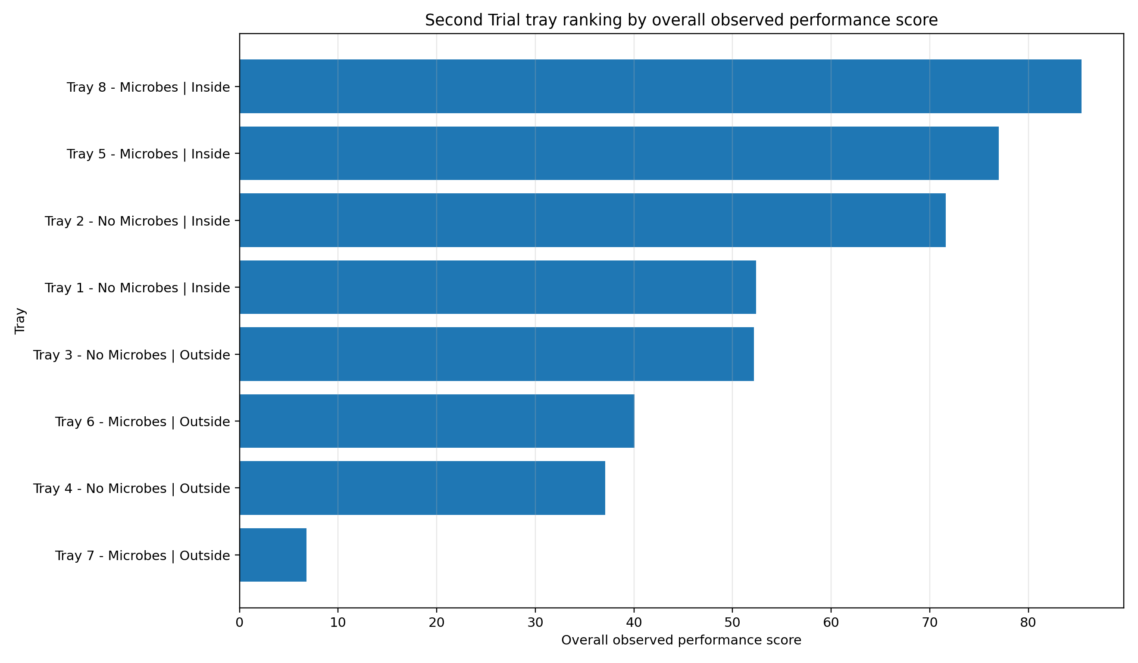
Figure 8. Final tray performance ranking by overall observed score.
Table 7. Final treatment x environment group summary.
Group | Trays | Day 5 emergence (%) | Day 5 RGB green cover (%) | Day 5 NDVI | Day 5 NDRE | Mean overall score | Best tray rank
Microbes | Inside | 2 | 92.14 | 3.22 | 0.2997 | -0.0572 | 81.21 | 1
No Microbes | Inside | 2 | 72.14 | 1.94 | 0.2960 | -0.0644 | 62.01 | 3
No Microbes | Outside | 2 | 65.00 | 0.99 | 0.2994 | -0.0734 | 44.62 | 5
Microbes | Outside | 2 | 53.57 | 0.68 | 0.2801 | -0.0703 | 23.42 | 6

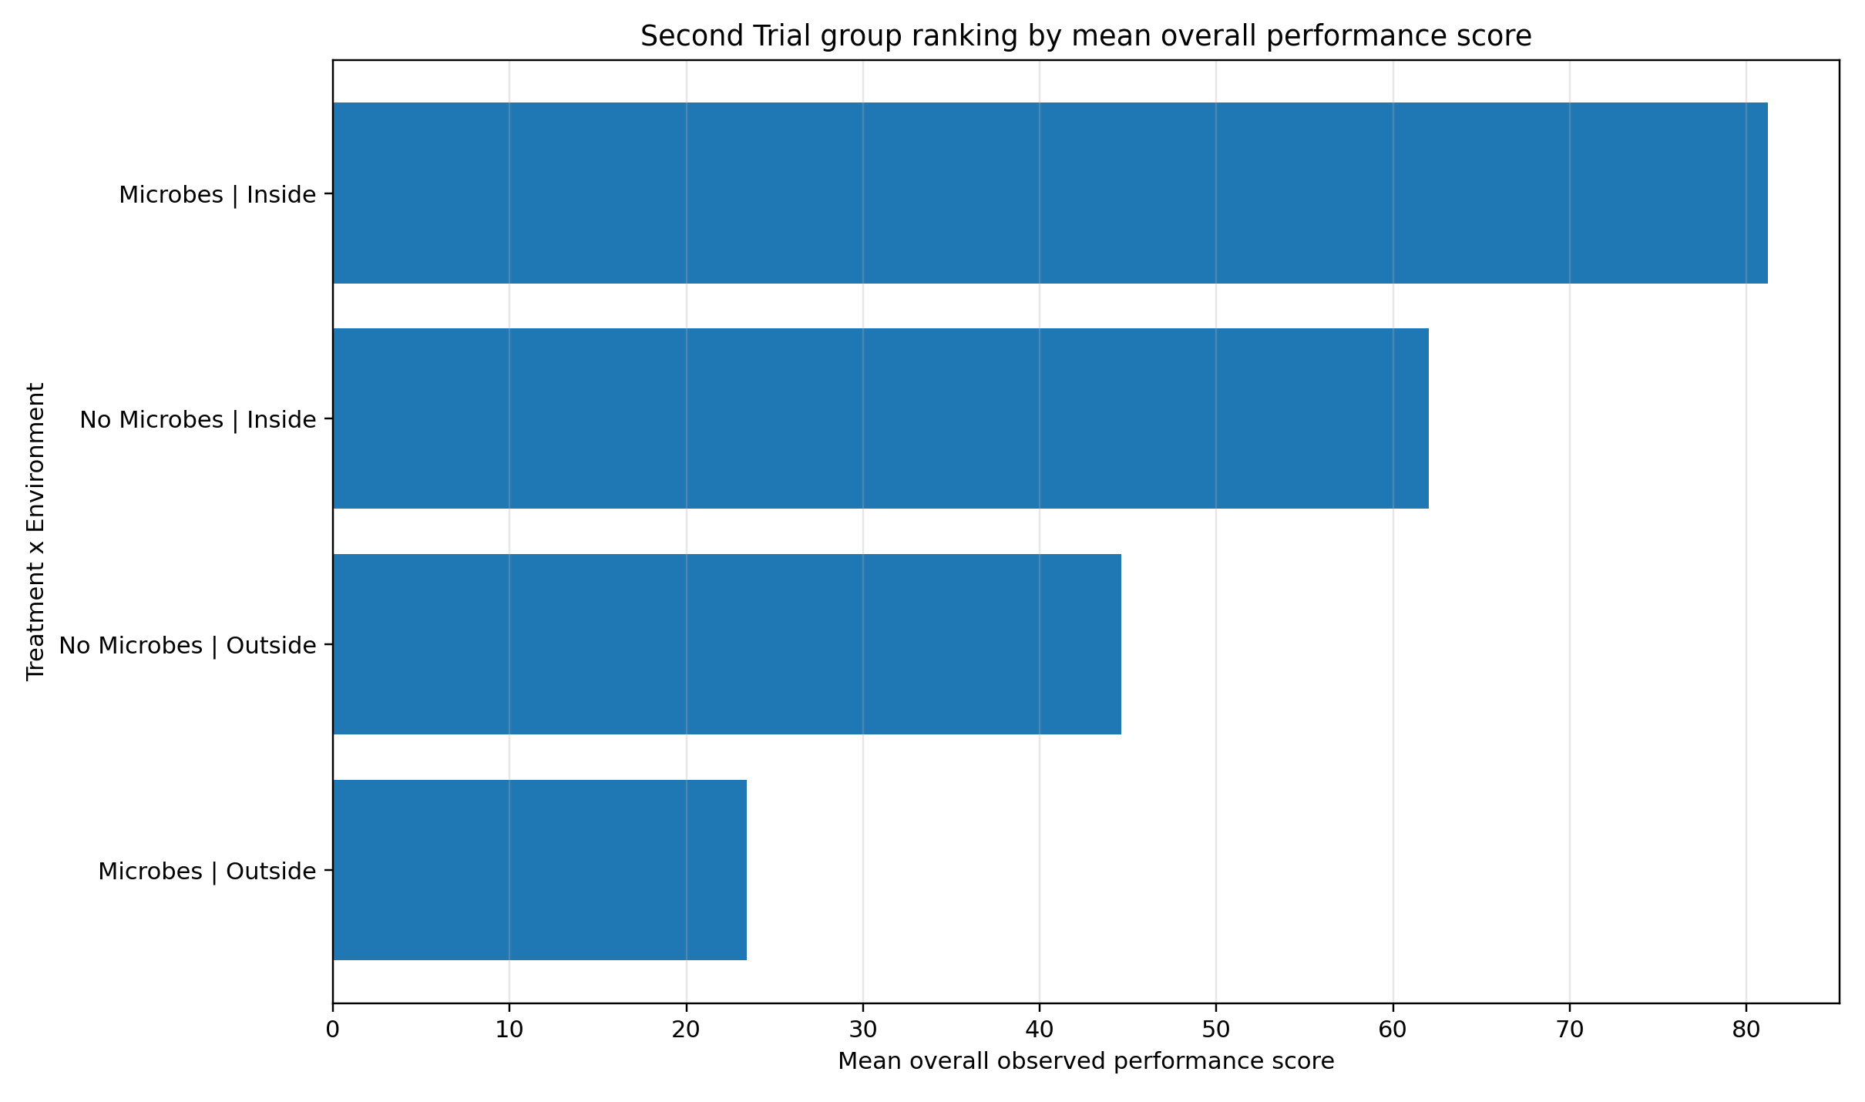
Figure 9. Final treatment x environment group ranking.
The final ranking clearly identified Microbes | Inside as the strongest treatment x environment group. This group achieved a mean overall score of 81.21, a mean Day 5 emergence of 92.14%, a mean Day 5 RGB green-cover proxy of 3.223%, a mean Day 5 NDVI of 0.2997, and a mean Day 5 NDRE of -0.0572.
The highest ranked individual tray was Tray 8, a Microbes Inside tray, with an overall observed performance score of 85.41. The second ranked tray was Tray 5, also Microbes Inside, with a score of 77.01. This provides strong descriptive evidence that the Microbes Inside condition produced the most favourable combined image-derived response in this trial.
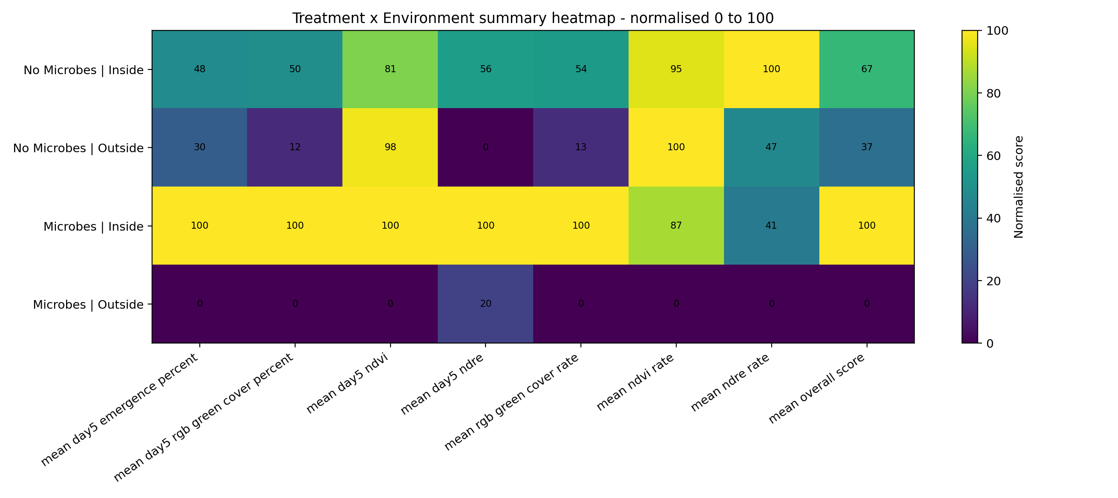
Figure 10. Treatment x environment heatmap of normalised summary indicators.

7.1 Agreement Between RGB and Multispectral Indicators
The final synthesis also compared RGB green-cover values with multispectral indices. This comparison was important because RGB and multispectral imagery measure related but different aspects of vegetation response. RGB green cover primarily indicates visible canopy area, while NDVI and NDRE respond to spectral differences between vegetation and background materials.
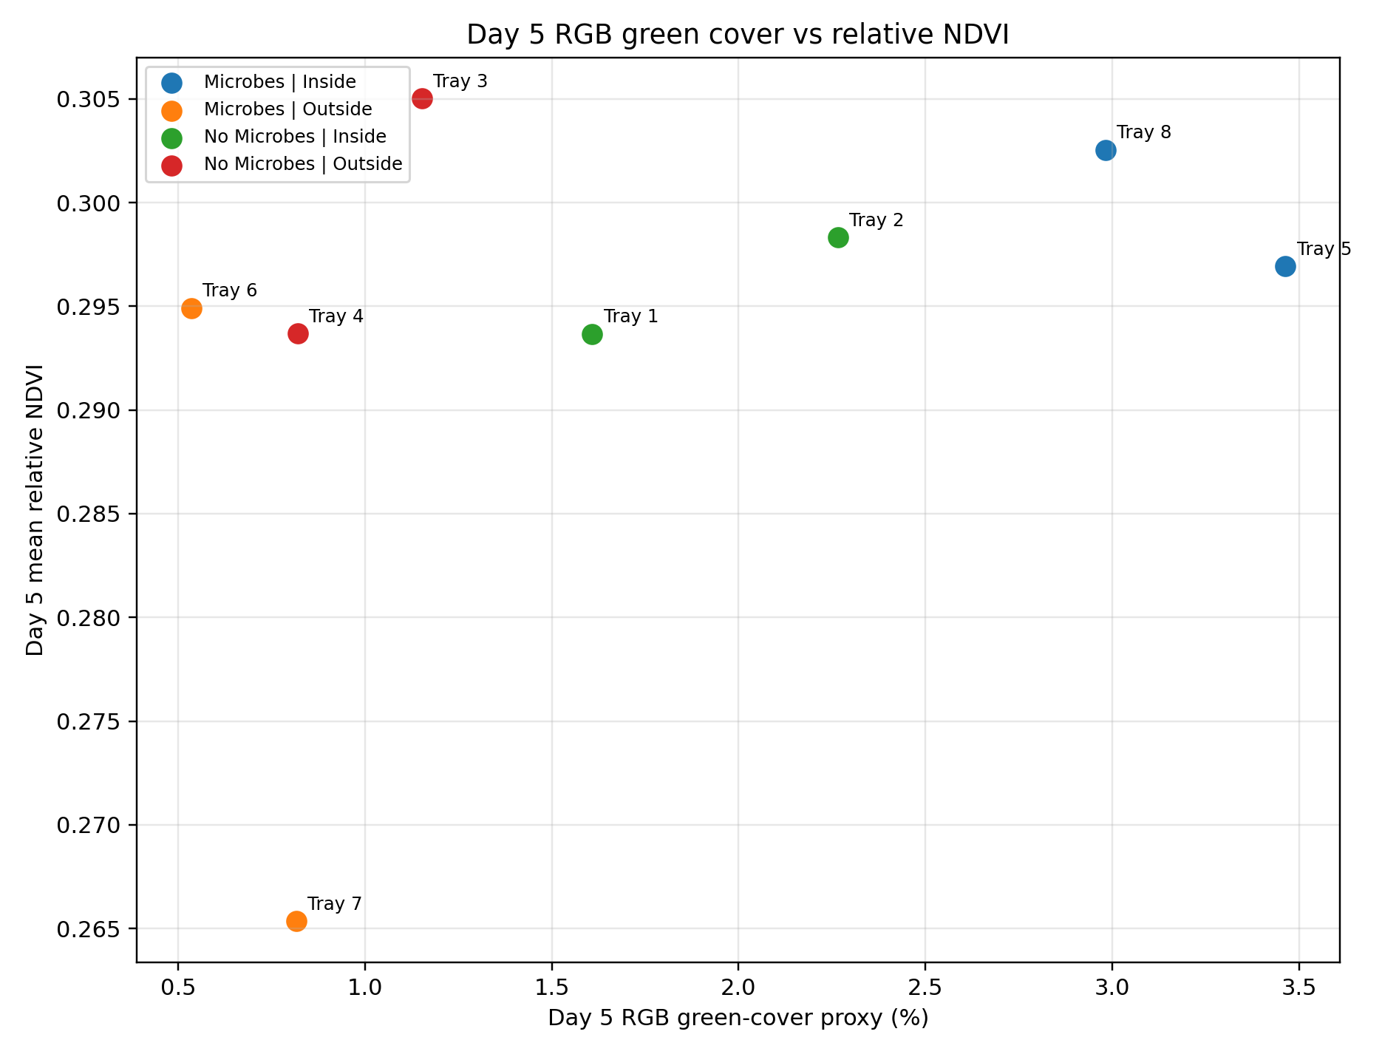
Figure 11. Day 5 RGB green cover versus relative NDVI.
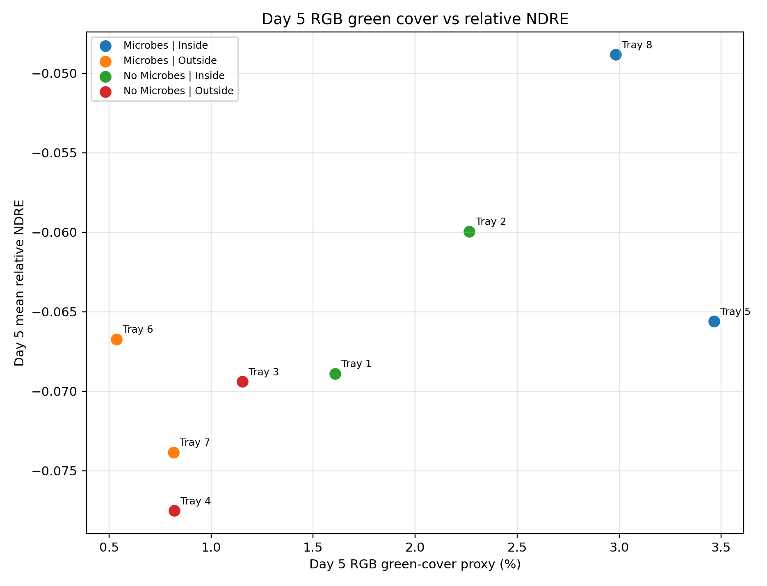
Figure 12. Day 5 RGB green cover versus relative NDRE.
The RGB and multispectral evidence did not always move identically. This is expected because visible green cover and spectral vegetation response are not identical measurements. However, the combined results still identified Microbes Inside as the strongest overall group because it performed well across the most important visible and spectral indicators.

8. Discussion
The Second Trial results show that treatment response depended strongly on both microbial treatment and placement environment. Microbes Inside was the strongest combined group, while Microbes Outside was the weakest. This pattern suggests that the microbial treatment was not uniformly beneficial across all placement conditions; rather, its effect appeared favourable when combined with the inside placement condition.
The RGB results provided the clearest evidence of growth differences. Microbes Inside had the highest Day 5 emergence, highest Day 5 RGB green-cover proxy, and the strongest RGB green-cover growth rate. These visible growth indicators are important because they directly reflect the visible establishment of seedlings in the tray cells.
The multispectral results were more mixed at the broad treatment level. No Microbes had a slightly higher broad Day 5 NDVI than Microbes, while Microbes had a stronger Day 5 NDRE. At the interaction level, however, Microbes Inside showed strong multispectral performance and also achieved the best combined overall score. This confirms the value of analysing the four treatment x environment groups rather than relying only on the broad Microbes versus No Microbes comparison.
A key outcome of the workflow was the creation of a repeatable analysis structure. Separate grid detection for RGB and multispectral images was necessary because the image geometries differed. The final workflow avoided transferring D/RGB coordinates directly to MS images and instead generated independent multispectral cell zones. This improved the reliability of the NDVI and NDRE calculations.
Overall, the Second Trial produced a coherent descriptive result: Microbes Inside was the strongest group, No Microbes Inside also performed reasonably well, No Microbes Outside was weaker, and Microbes Outside was the weakest. This indicates that the relationship between microbes and placement environment should be considered in future trials.

9. Limitations
Several limitations must be considered when interpreting the results.
- The results are image-derived indicators rather than direct biological measurements such as biomass, root length, or laboratory chlorophyll concentration.
- The NDVI and NDRE values should be treated as relative image-derived vegetation indices unless the original multispectral bands are confirmed as calibrated reflectance products.
- Each treatment x environment group contained only two trays, so the results support descriptive comparison rather than formal statistical proof.
- Image-processing outputs can be affected by crop quality, lighting, tray alignment, and the accuracy of the cell-grid detection.
- Day 9 was a later follow-up observation rather than a regular daily interval after Day 5, so growth rates were calculated only for the Day 1 to Day 5 window.
- One intermediate multispectral Day/Tray record was missing from the accepted daily MS dataset, although the key final tray-level metrics used in the synthesis were available.
These limitations do not invalidate the workflow. Instead, they define the appropriate interpretation: the Second Trial results should be used as structured descriptive evidence and as a reproducible image-analysis workflow that can be expanded with additional trials and replication.

10. Conclusion
The Second Trial image-analysis workflow was successfully completed. The workflow processed D/RGB and multispectral imagery, detected the fixed 70-cell tray structure, measured visible emergence and RGB green cover, calculated relative NDVI and NDRE, compared treatment groups, and produced a final report-ready synthesis package.
Visible emergence increased from 36.96% on Day 1 to 70.71% on Day 5 and reached 74.29% by Day 9. The strongest individual trays were Tray 8 and Tray 5, both in the Microbes Inside group. The strongest combined treatment x environment group was Microbes | Inside, with a mean overall score of 81.21.
The main conclusion is that Microbes Inside showed the strongest observed performance in the Second Trial. However, Microbes Outside performed poorly, so the broad microbial treatment result should be interpreted carefully. The trial suggests that placement condition may be critical for the effectiveness of microbial treatment in this dataset.

